SQL Baseline enable example

**How to enable SQL Baseline**

After initial login to OEM as oracle dba. Select database target. Identify SQL ID and before running Tunning Advisor you will need Log to database target in OEM under you’re A/N oracle account (or system database account)

Go to ORACLEDBA click Log Out

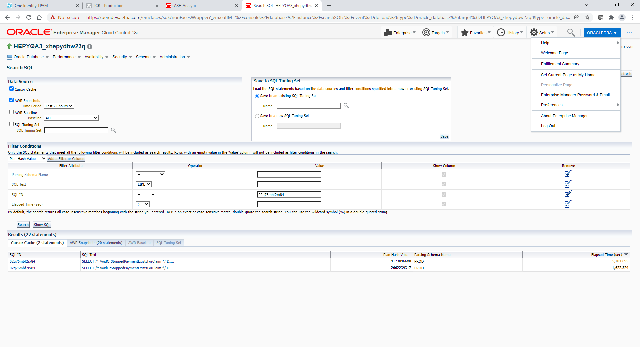

Select Display login page after logout checkbox. Clock Logout button.

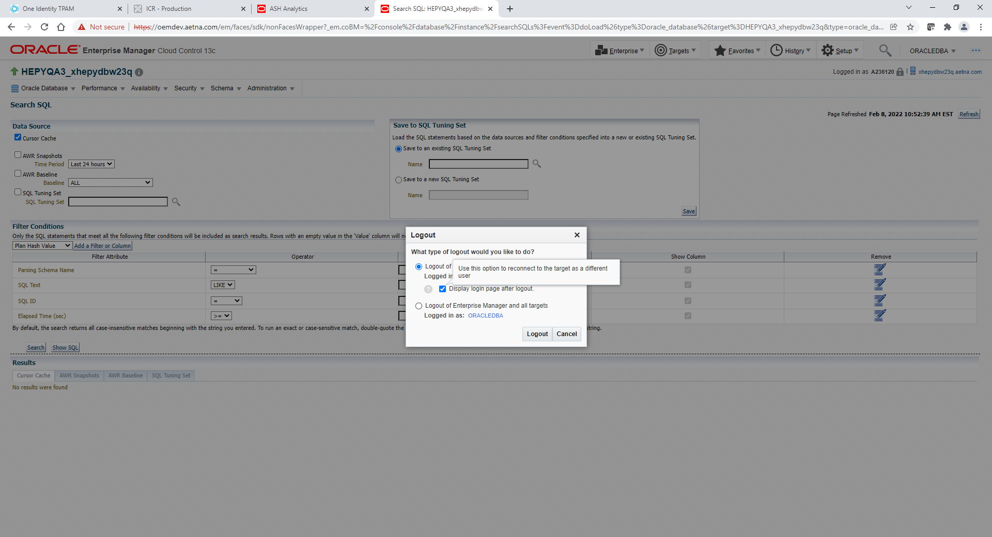

Select New and type your Oracle Database AID and P. Click Login.

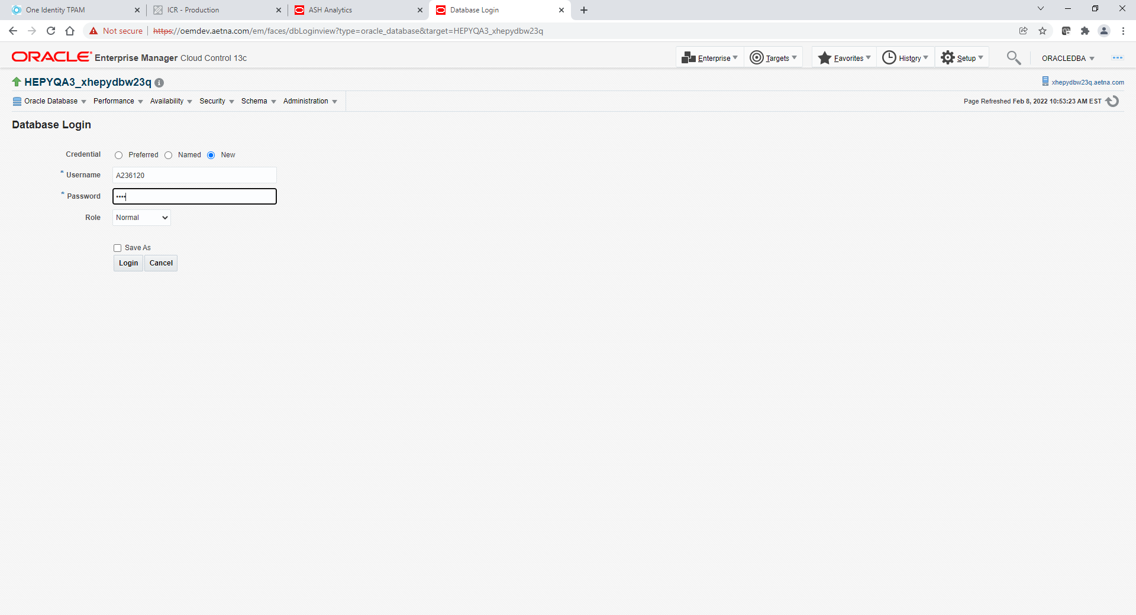

Go to Performance 🡪 SQL 🡪 SQL Tuning Sets

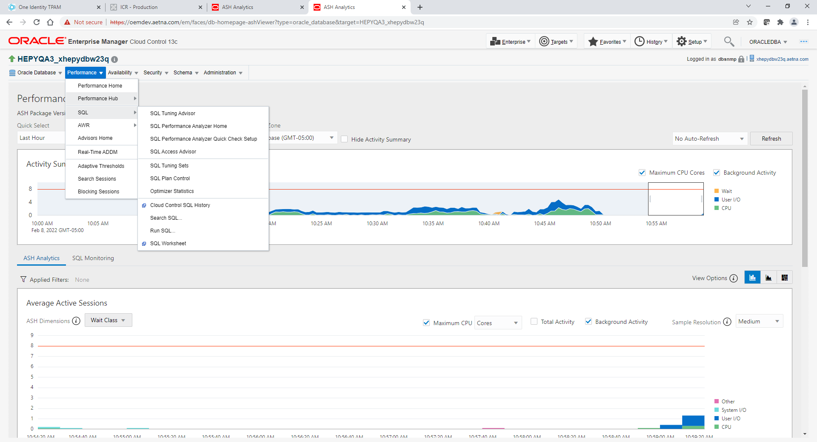

Click Create button

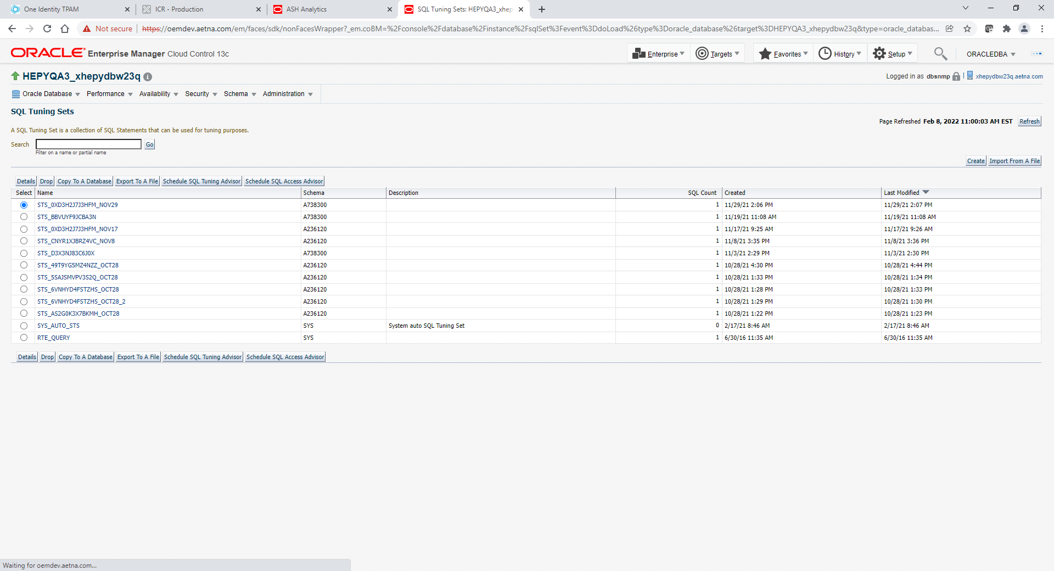

Just type meaningful SQL Tuning Set name and click Next

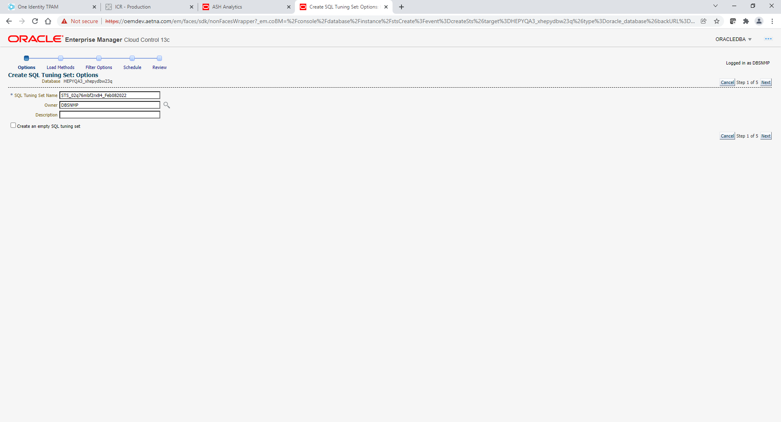

Select Load SQL statements one time only. Select AWR Snapshot for DataSource and whatever last days you want for AWR Snapshots date range.

Click Next

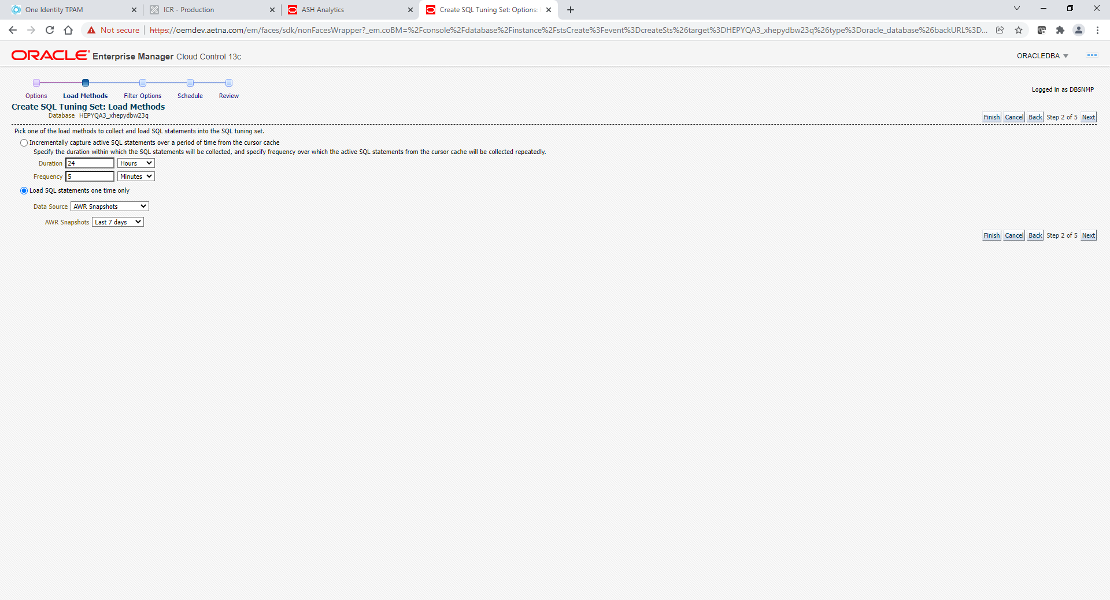

Specify SQL ID and click Next

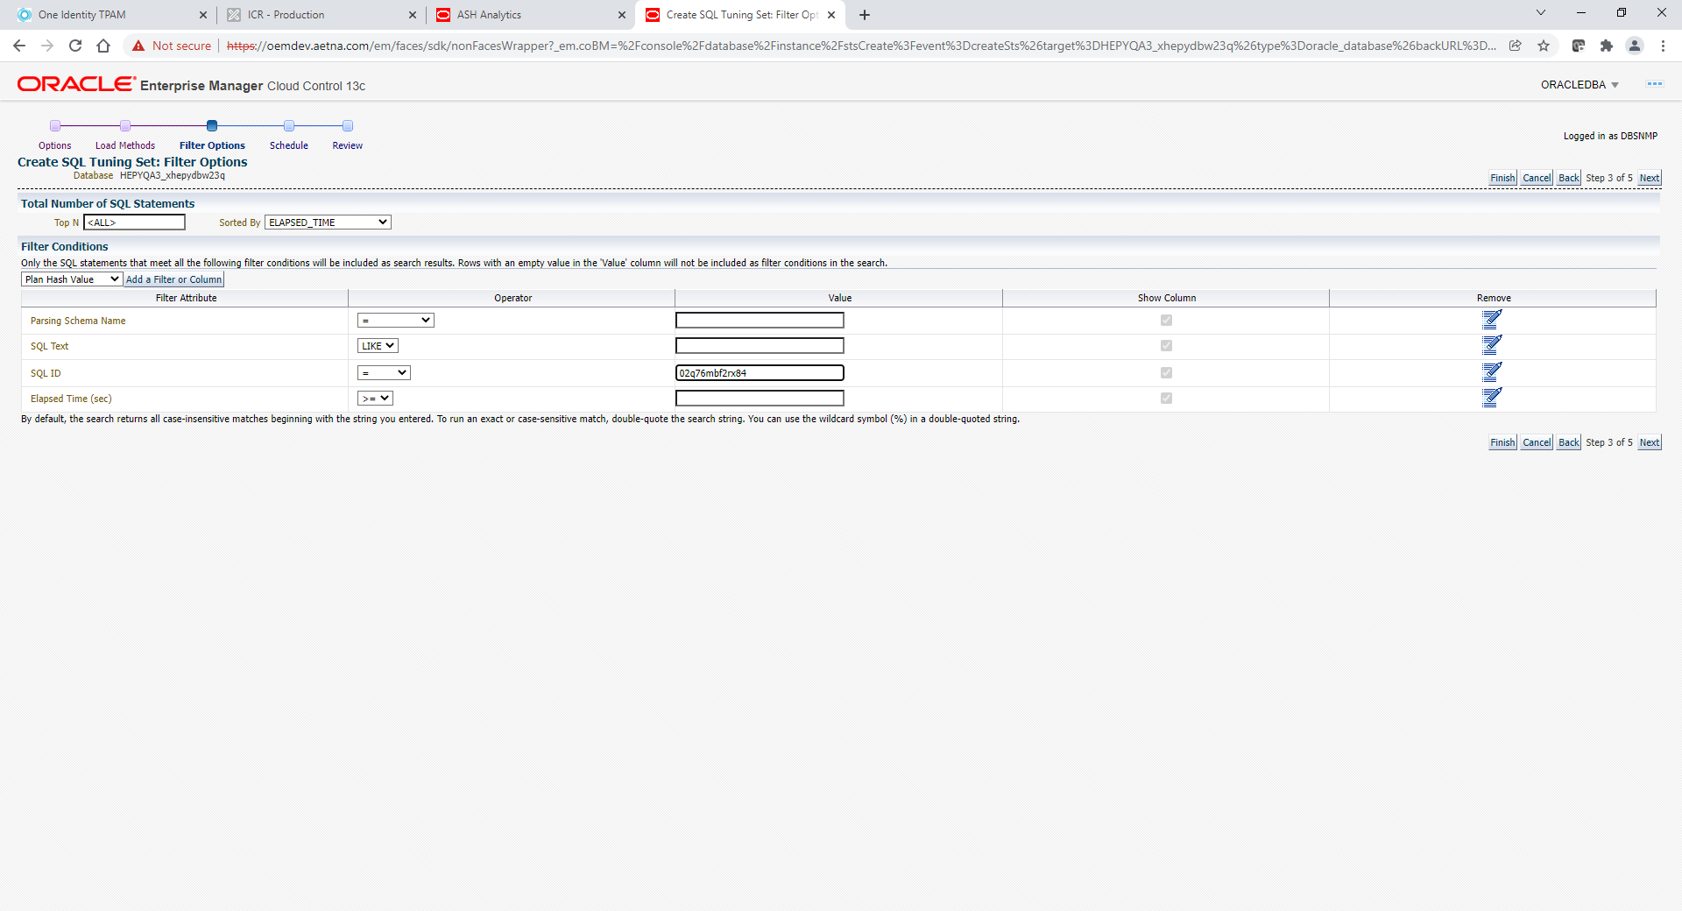

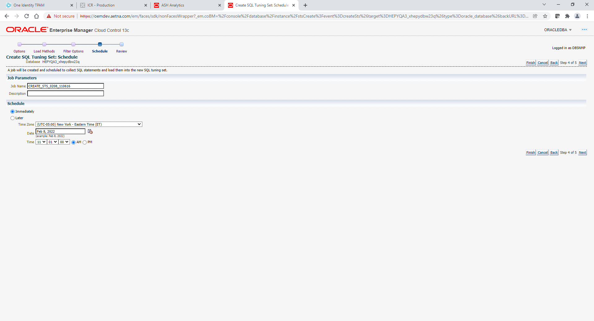

Click Next

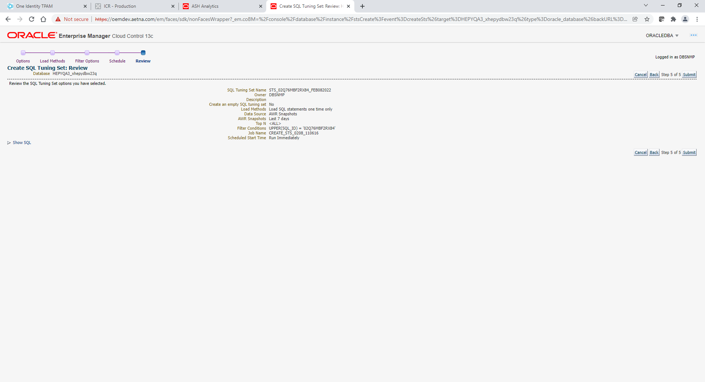

Click Submit

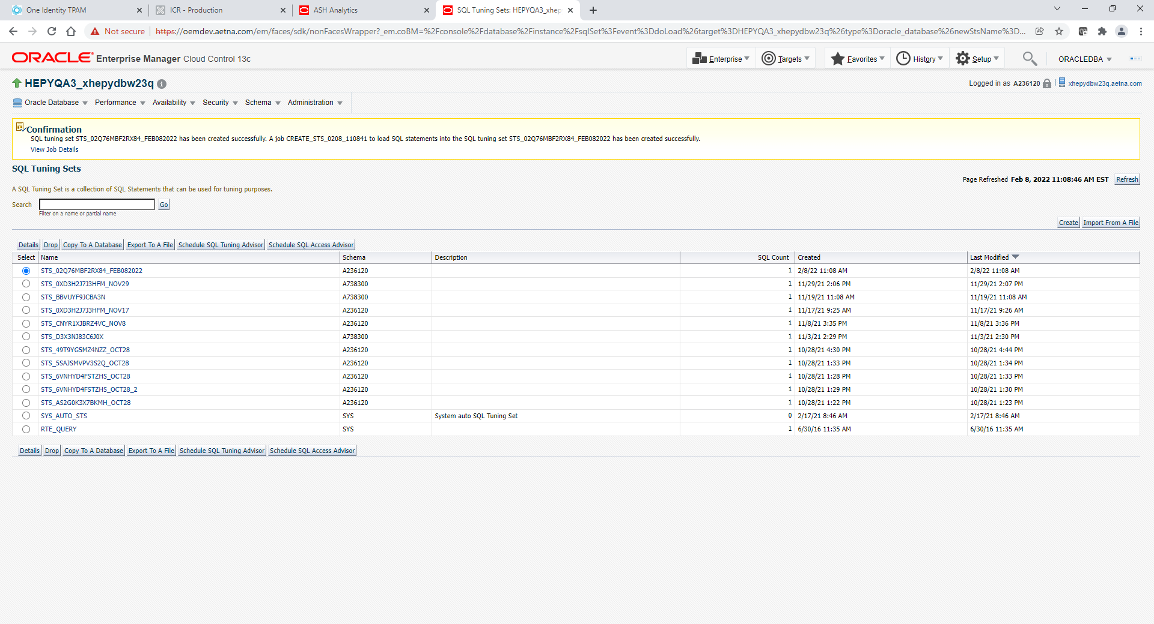

You should get back to SQL Tuning Sets page with successful Confirmation in yellow on top.

Click Refresh button

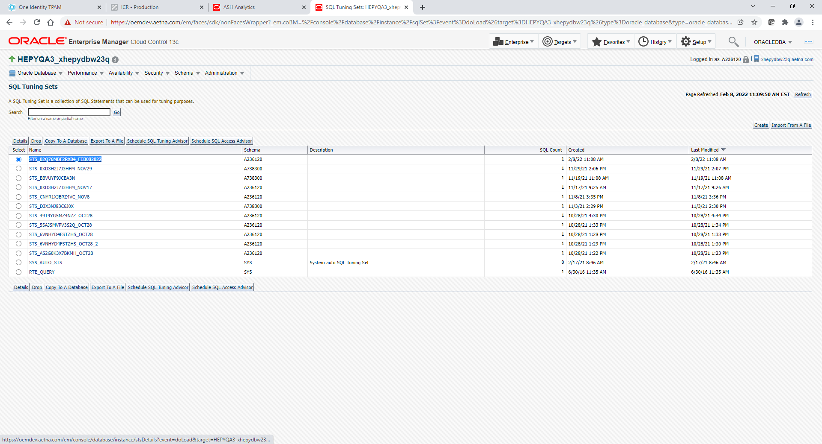

You should see your Tuning Set on top. Make sure SQL Count > 0. If not you may need to click Refresh button again.

Select your Tuning Set Name and click link.

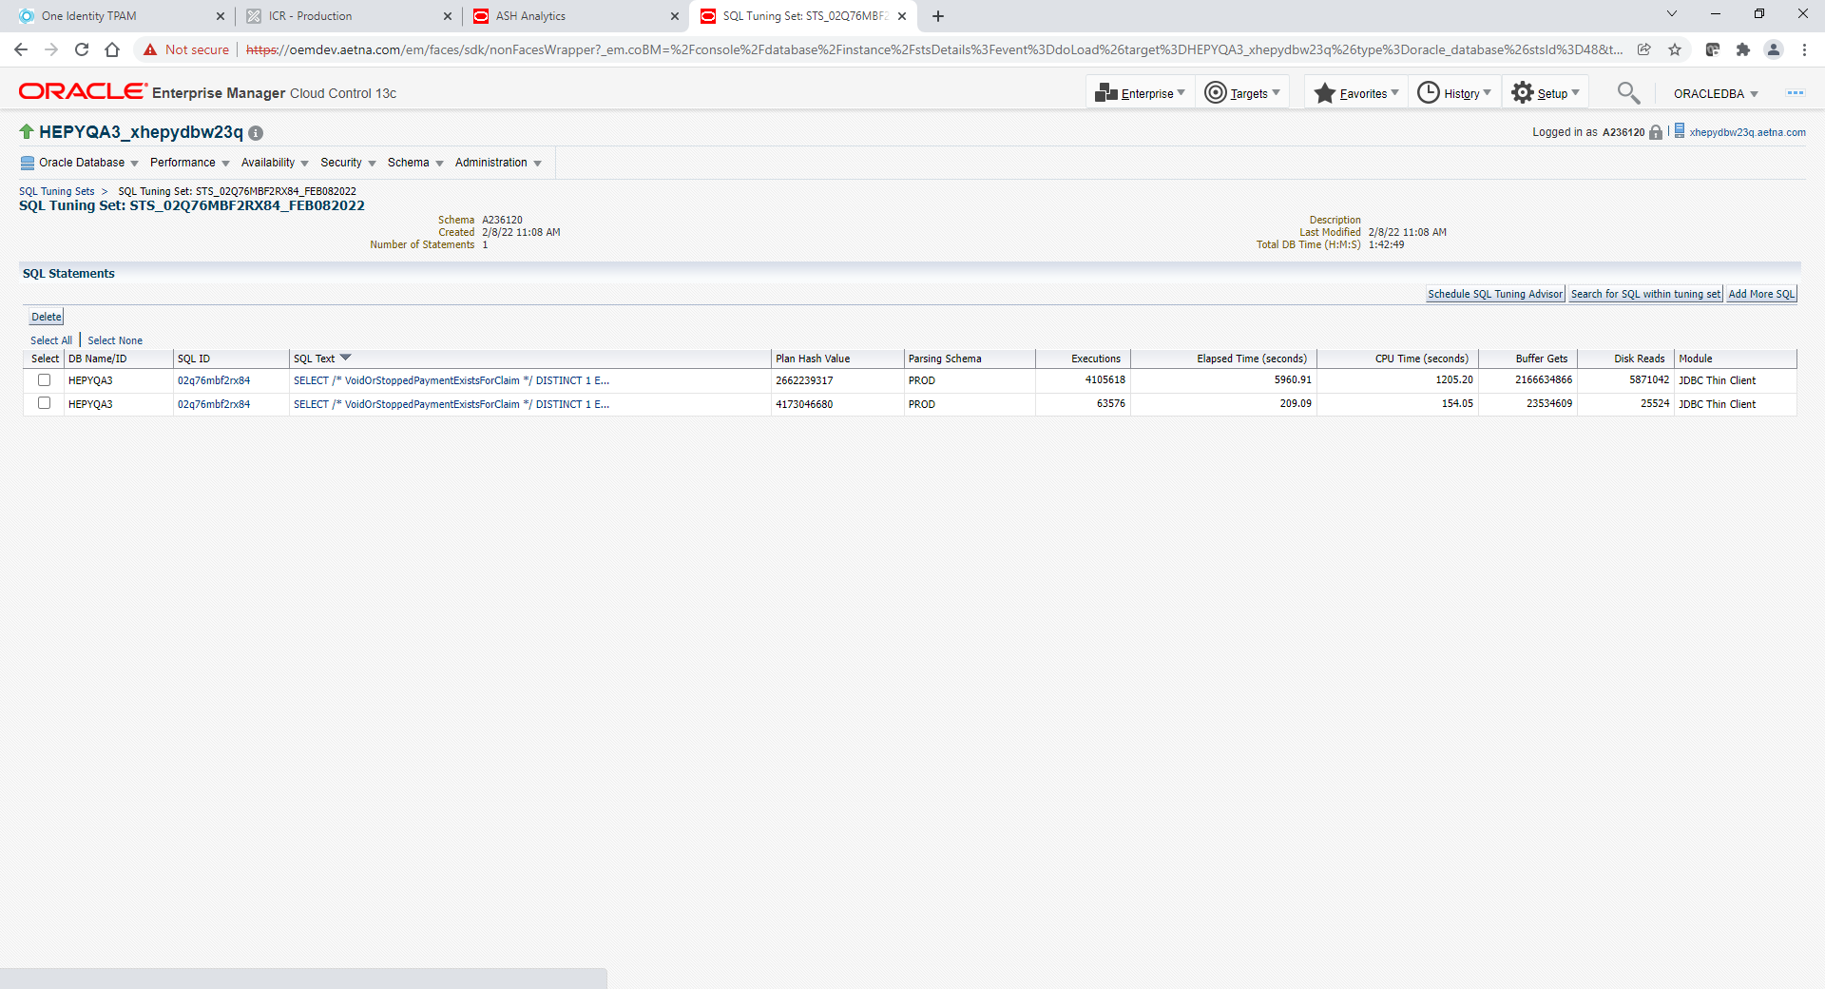

Select Plans that you do not want and delete them. You only need to leave one good plan that you intend to use for SQL Baseline.

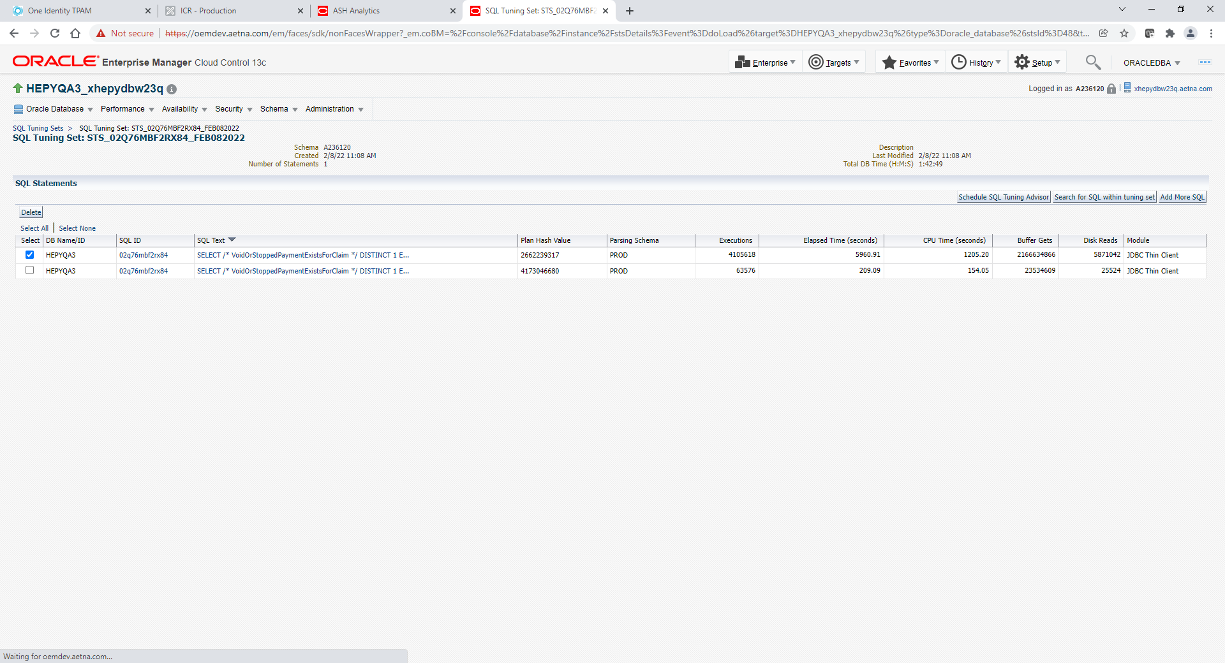

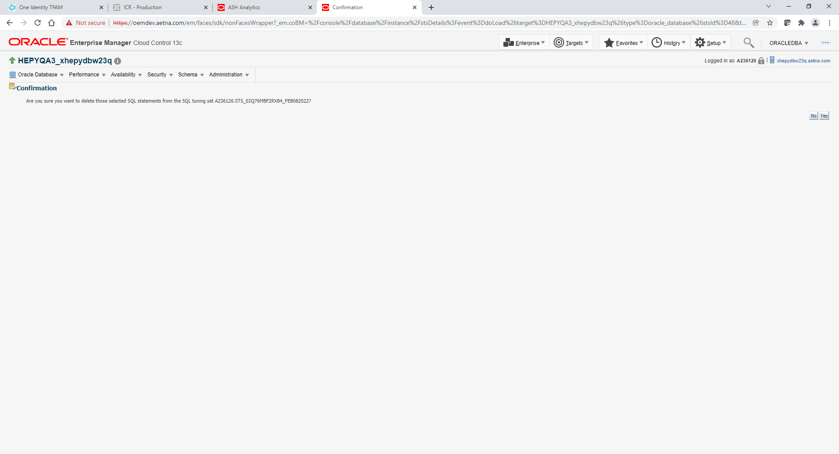

Click Yes

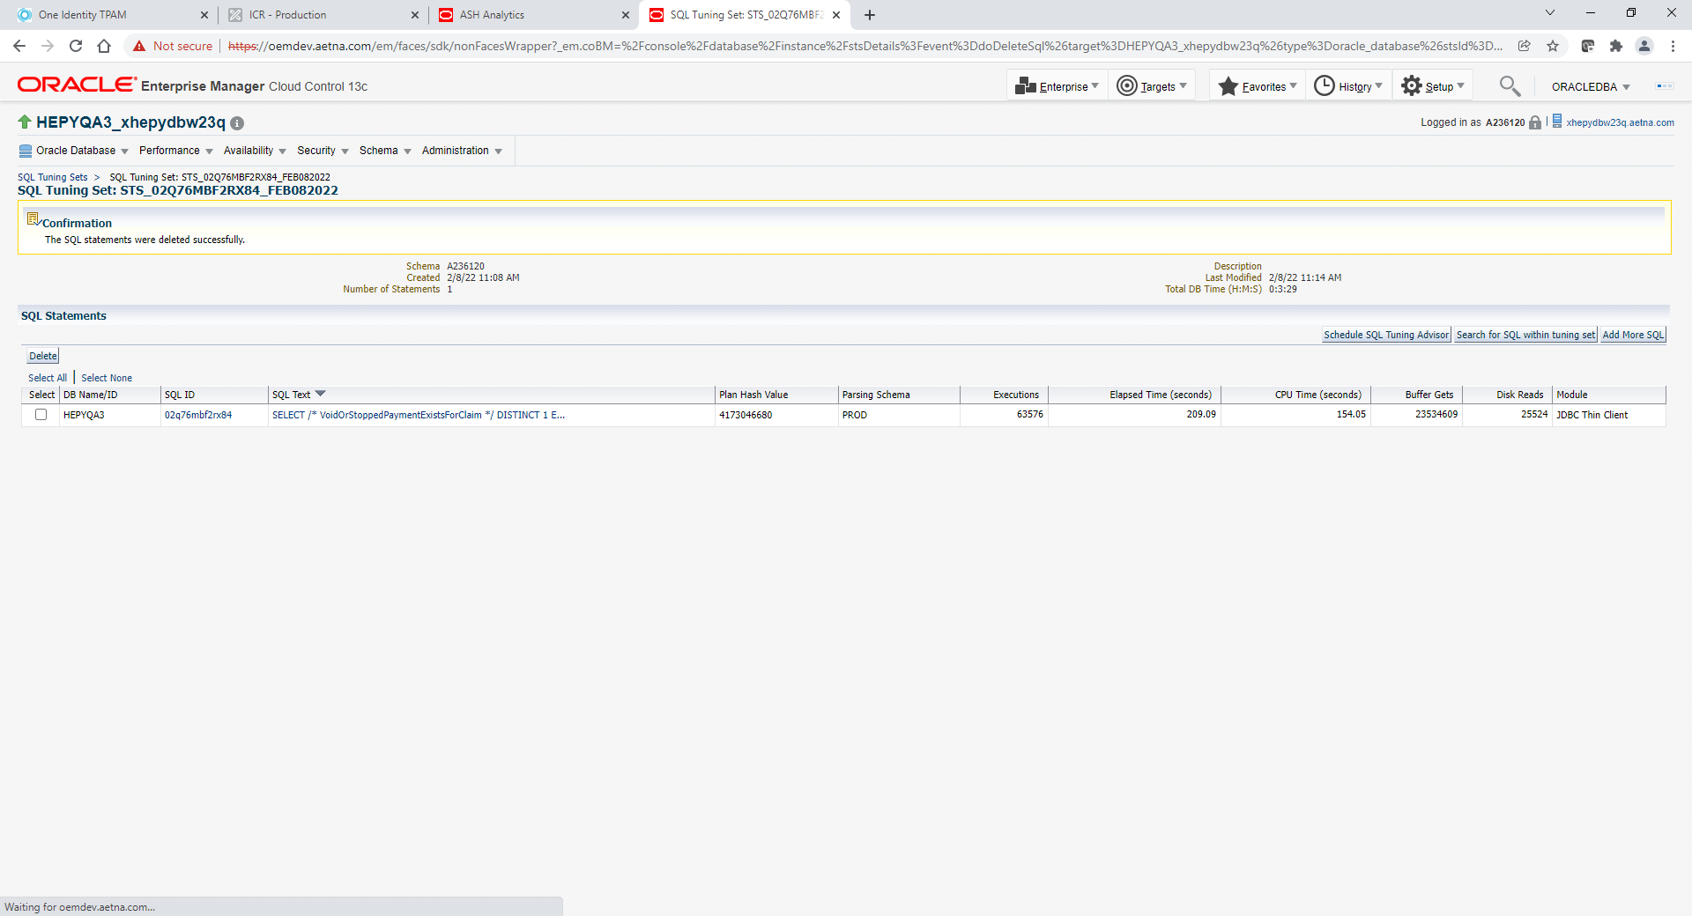

Go to Performance 🡪 SQL 🡪 SQL Plan Control

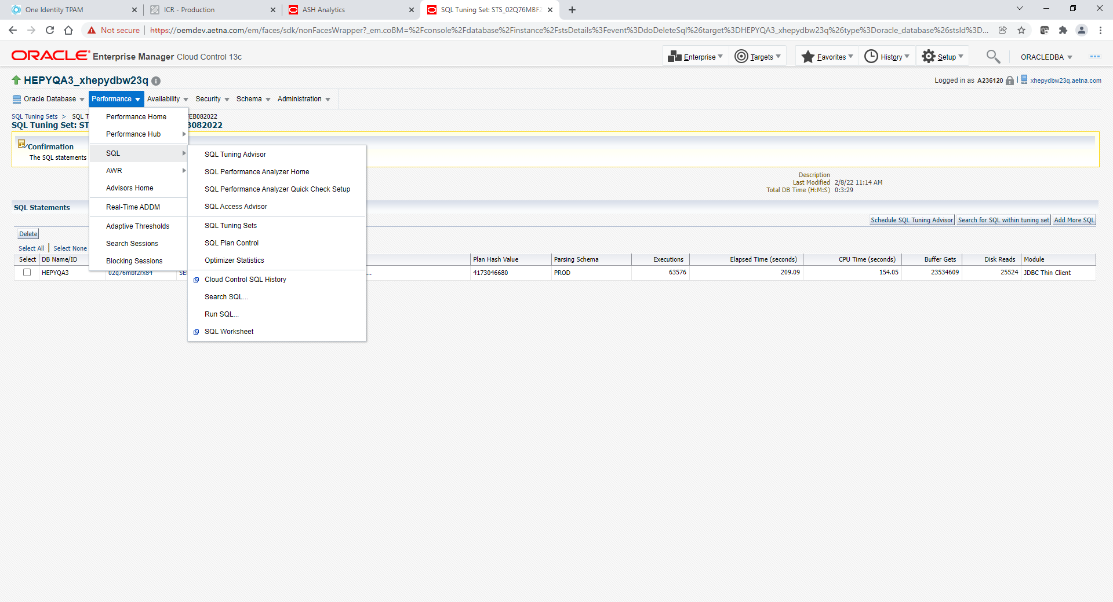

Select SQL Baseline Tab

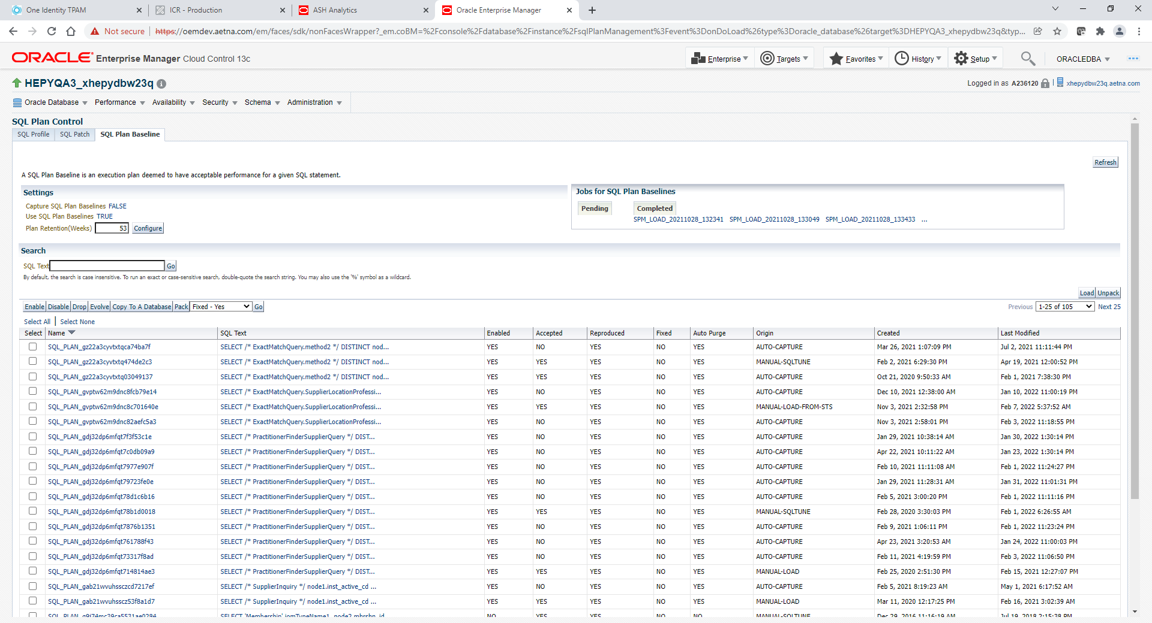

Click Load button

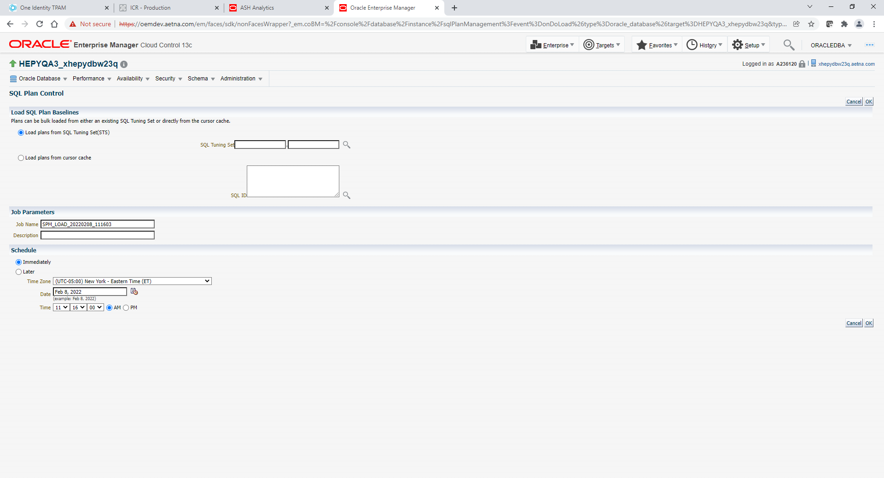

Specify SQL Tuning Set that you created. Use magnifier for search

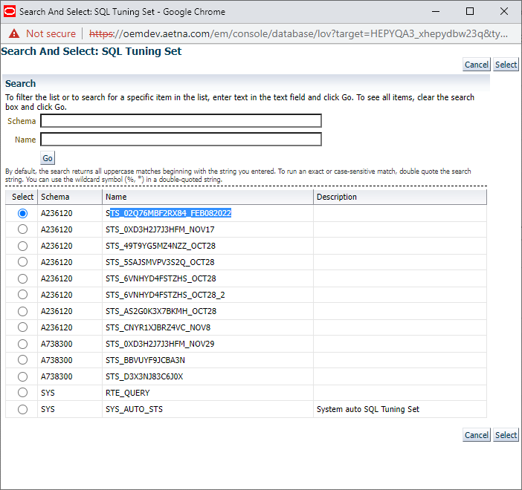

Select your tuning set and click Select. It will populate

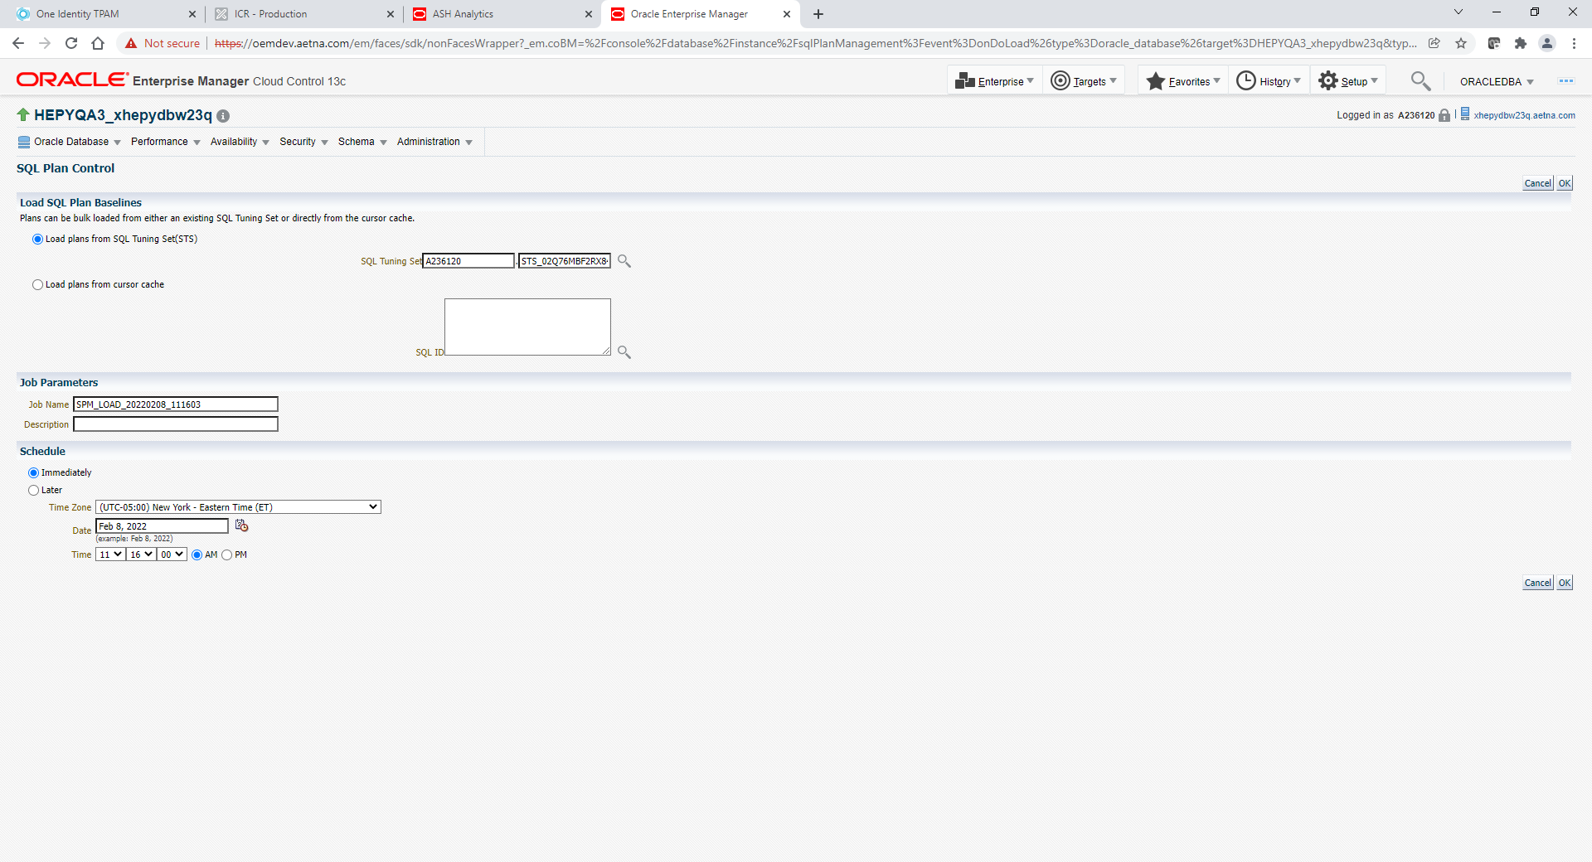

Click OK

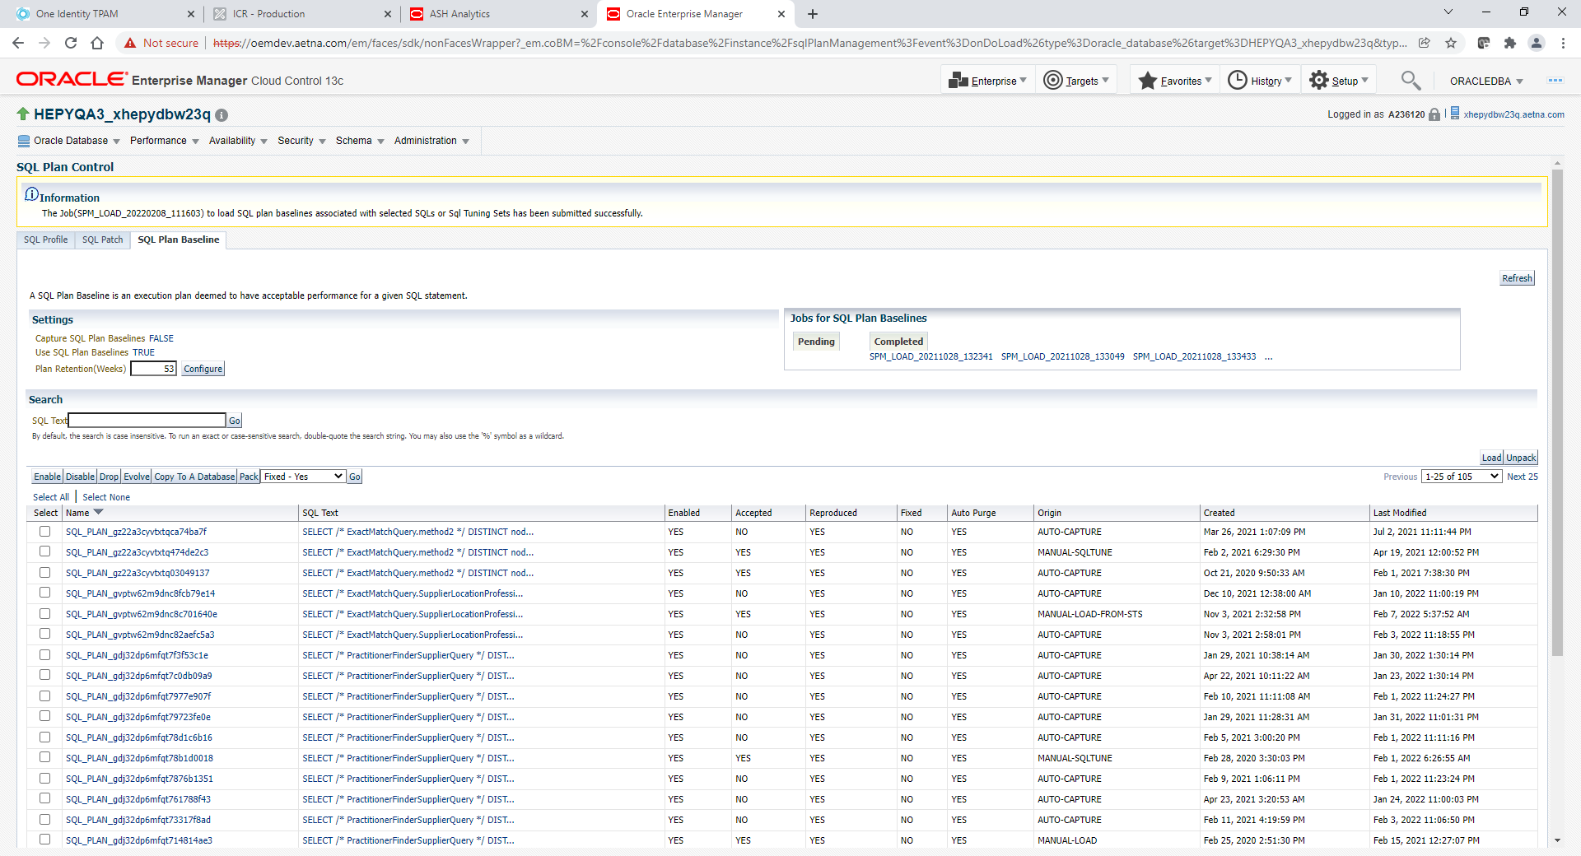

You should see Information on top of the screen that STS has been submitted successfully.

Click Refresh button and sort by Created column.

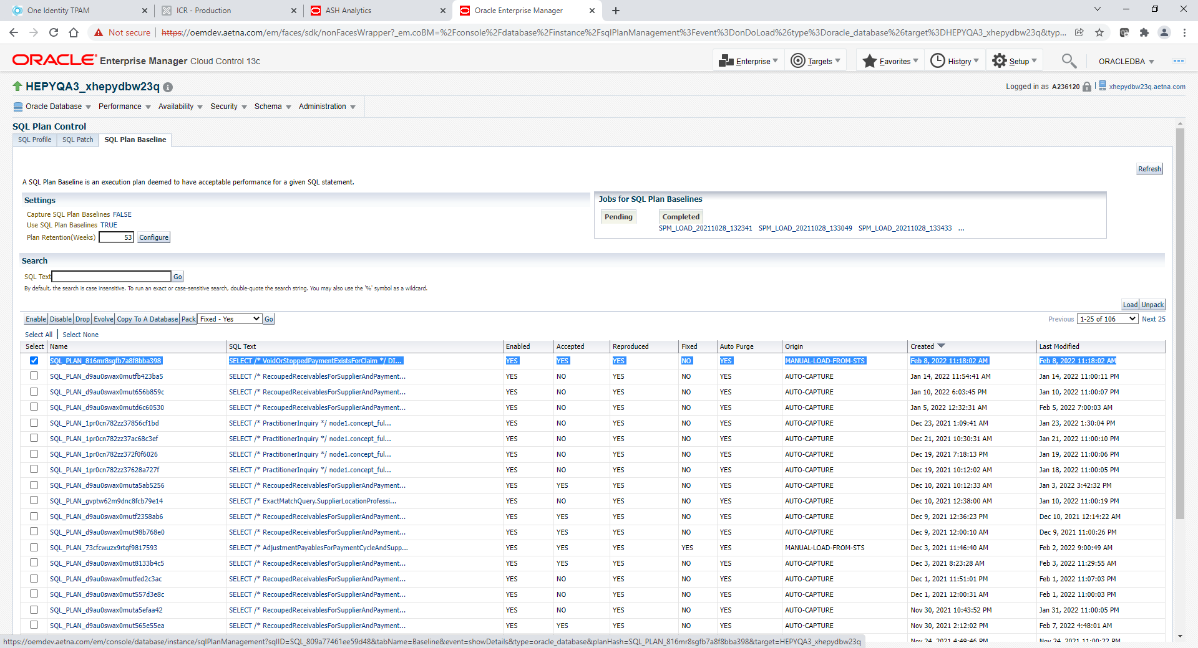

You should see your Tuning Set on top. It also should have MANUAL-LOAD-FROM-STS in Origin column

Select you’re your Tuning Set and click Fixed-Yes GO button.

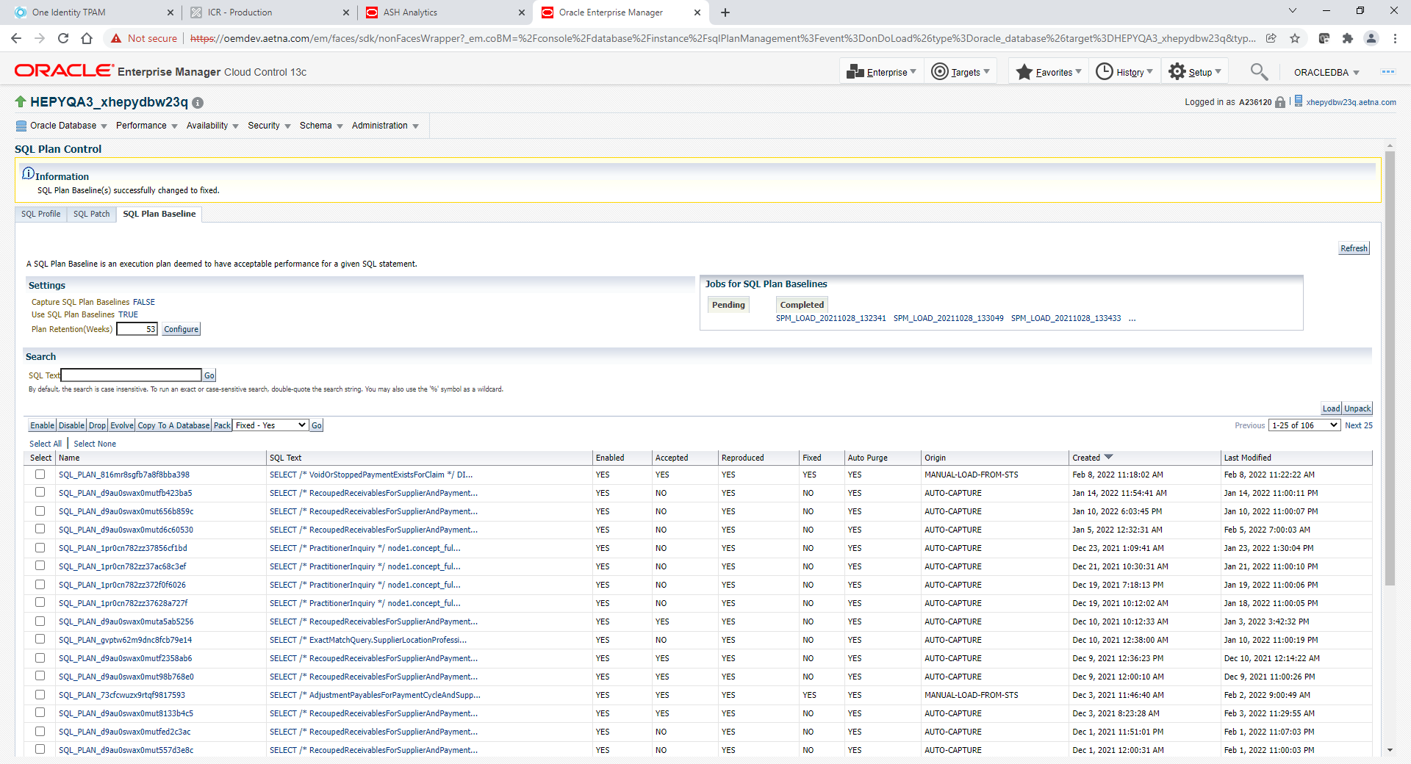

You should see Information message on top of the screen. SQL Plan Baseline(s) successfully changed to fixed.

This should enable SQL Baseline. Go back to your SQLID and verify.

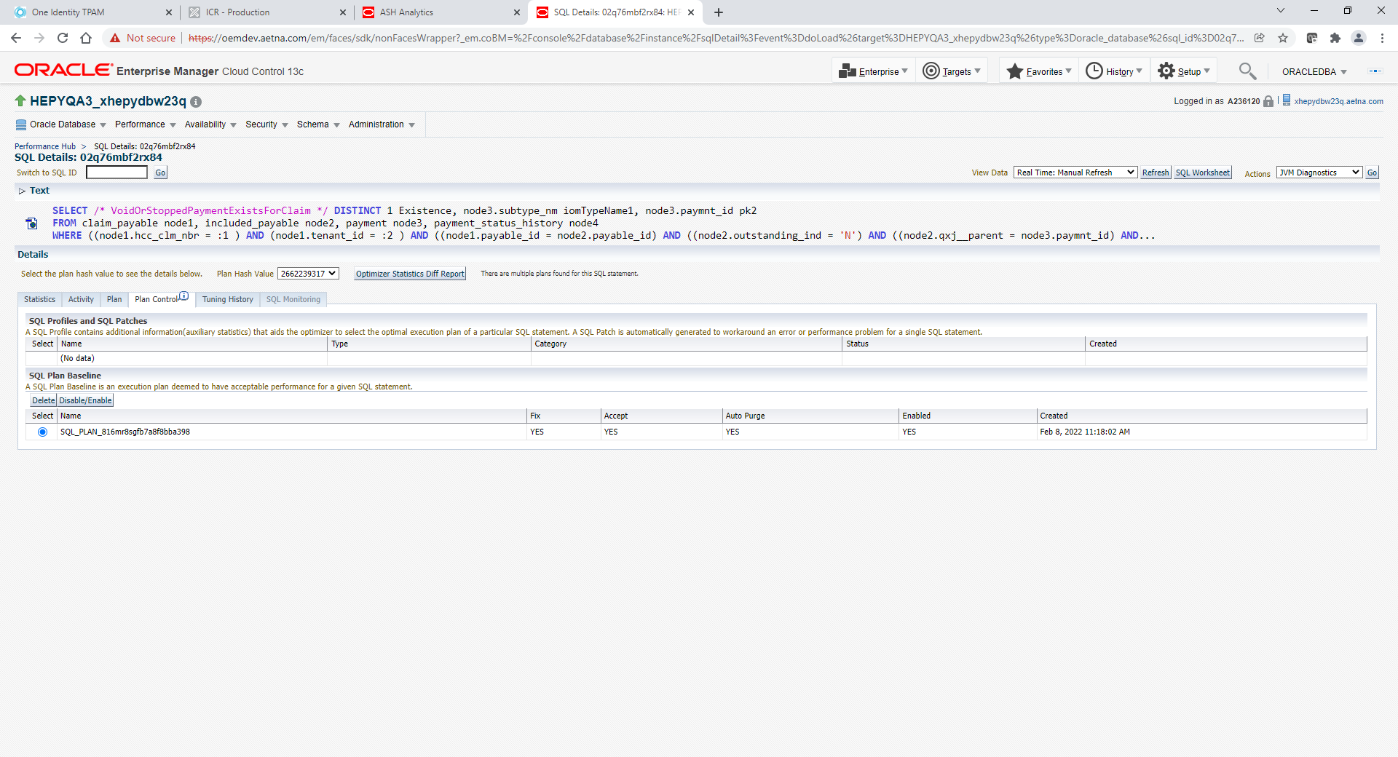

Next final steps to purge shared pool for this SQL ID

Run following query to retrieve address and hash_value

sqlplus / as sysdba

select address, hash_value, executions, loads, version_count, invalidations, parse_calls,sql_plan_baseline

from v$sqlarea

where sql_id = '02q76mbf2rx84';

Populate values from address and hash_value below and run from sqlplus

sqlplus / as sysdba

exec dbms_shared_pool.purge ('0000000095C34AA0, 3693868292','C');

You also may need to kill long running sessions to clear pile up if needed

1. Login to Linux server

. oraenv

DBNAME

3. sqlplus / as sysdba

4. spool kill.sql

5. select 'alter system kill session ''' || sid || ',' ||serial#|| ''';' from v$session where sql_id='cnyr1xjbrz4vc';

6. spool off

7. @kill.sql